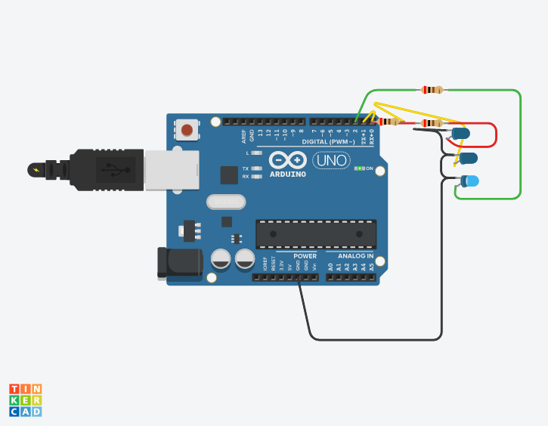 ***Project 2:- Led Chaser***

* *Theory:-*  In this experiment we going to make a led chaser with the help of three led lights, four wires , breadboard, arduino, a cable to connect computer with arduino. After this we have to according to the experiment we are going to perform using software which can apply code to arduino and our get run. Now moving towards hardware here we have to attach three led bulbs parallely the positive end are to connected to three wires and the other end are connected to arduino, while the negative end is grounded .
* *Observation:-*  After verifying and uploading the code we have observe that led start chasing each other as one turn on then turn off after some delay another one and continuing the same pattern until we changing the code or command
* *Problems:-* You should take care whether board in Arduino on or not and also selection of slots in code for positive terminal of leds are connected in similar pattern or not most of do mistakes in that
* *Precaution:-*  Wires should be connected in proper manner in board and ardunio. While installing led take care of the terminals as big wire is for positive terminal and small is for negative.
* *Learning outcomes:-*  With this experiment we can learn how to make led chaser with the of coding in this experiment we are not using any type of battery because here arduino act as a power supplier. As we also learn that led is a output device which read and apply the code.